**Question:** Write a program for implementing the Linear Search.

**Algorithm:**

Step-1: Read the search element from the user.

Step-2: Compare the search element with the first element in the list.

Step-3: If both are matched, then display “Given element is found!!!” and terminate the

function.

Step-4: If both are not matched, then compare search element with the next element in the

list.

Step-5: Repeat steps 3 and 4 until search element is compared with the last element in the list.

Step-6: If the last element in the list also doesn’t match, then display “Element is not

found!!!” and terminate the function.

**Code:**

#include<iostream.h>

#include<conio.h>

#include<stdio.h>

void main()

{

clrscr();

int key,i,count=0,len,array[20];

cout<<"Enter the length of the array:";

cin>>len;

cout<<"Enter the elements:";

for(i=0;i<len;i++)

{

cin>>array[i];

}

cout<<"Enter the key to search:";

cin>>key;

for(i=0;i<len;i++)

{

if(array[i]==key)

{

count++;

}

}

cout<<"The element is found in the array"<<" "<<count<<" times";

if (count==0)

{

cout<<"The element is not found in the array";

}

getch();

}

**Output:**

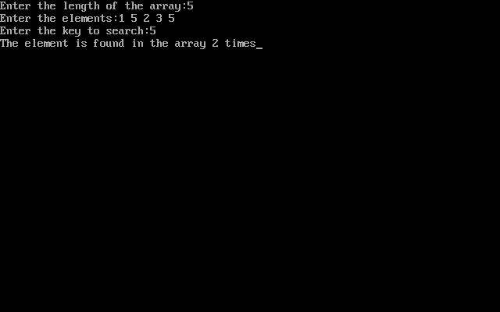

**Complexity:**

Best Case : O(1)

Average Case : O(n)

Worst Case : O(n)